***DBMS PRACTICAL ASSIGNMENT- 1***

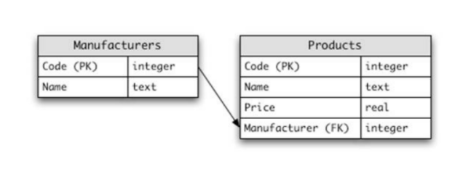

***Body for above schema :***

create table manufactureres

(

code_PK number(5),

name varchar2(20),

primary key(code_PK)

);

desc manufactureres;

drop table manufactureres

create table products

(

code_PK number(5),

name varchar2(20),

Price number(7),

Manufacturer number(5),

primary key(code_PK),

foreign key (manufacturer) references manufactureres(code_PK)

);

select * from products;

select * from manufactureres;

insert into manufactureres

values(11005,'xioami');

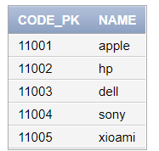

insert into products

values(11221 , 'android mobile',21000 ,11003 );

insert into products

values( 11222, 'power Bank', 3145 ,11002 );

insert into products

values( 11223, 'laptop', 71000, 11002);

insert into products

values( 11224, 'iPhone 13', 41050 , 11001);

insert into products

values( 11225, 'PC',65999 ,11005 );

insert into products

values( 11226, 'ipod', 34555, 11003 );

insert into products

values( 11227, 'lcd', 67999, 11004);

insert into products

values(11228 , 'copy machine', 23000, 11004);

insert into products

values(11229 , ' avionics', 3400, 11005);

insert into products

values( 11230, 'harddisk', 200,11003 );

insert into products

values( 11231, 'cd', 72,11002 );

insert into products

values( 11232, 'pendrive', 50,11005 );

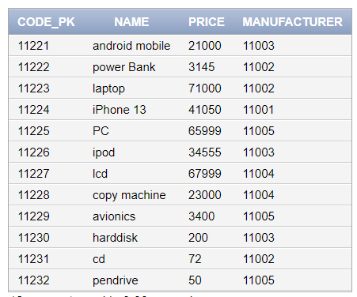

1. **Select the names of all the products in the store.**

select name from products;

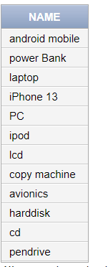

1. **Select the names and the prices of all the products in the store.**

select name , price from products;

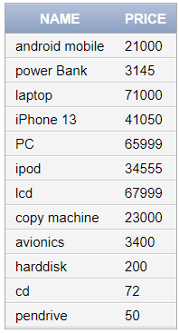

1. **Select the name of the products with a price less than or equal to 200.**

select name from products where price<=200;

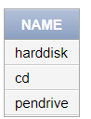

1. **Select all the products with a price between 60 and 120.**

select * from products where price >60 and price <120;

select * from products where price between 60 and 120;

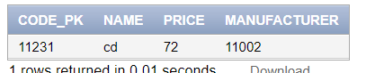

1. **Select the name and price in cents (i.e., the price must be multiplied by 100).**

select name , price*100 cent from products;

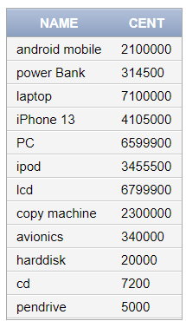

1. **Compute the average price of all the products.**

select avg(price) from products;

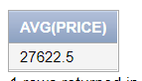

1. **Compute the average price of all products with manufacturer code equal to 2**.

select avg(price) from products where Manufacturer = 11002;

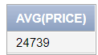

1. **Compute the number of products with a price larger than or equal to 180.**

select count (*)from products where price >=180;

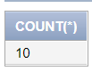

1. **Select the name and price of all products with a price larger than or equal to $180, and sort first by price (in descending order), and then by name (in ascending order).**

select name , price from products where price >=180 order by price desc , name asc;

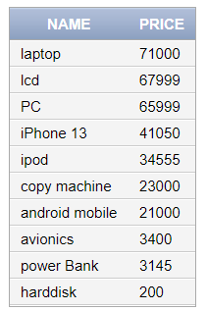

1. **Select all the data from the products, including all the data for each product's manufacturer.**

select p.* , m.name from products p inner join manufactureres m on p.manufacturer =m.code_PK ;

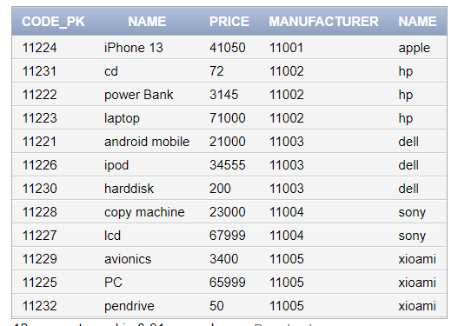

1. **Select the product name, price, and manufacturer name of all the products.**

select p.name,p.price , m.name from products p inner join manufactureres m on p.manufacturer =m.code_PK ;

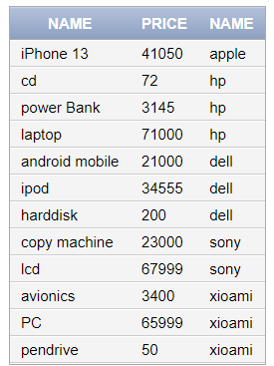

1. **Select the average price of each manufacturer's products, showing only the manufacturer's code.**

select avg(price) , manufacturer from products group by manufacturer;

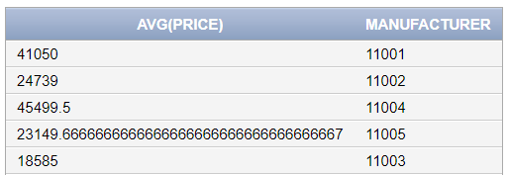

1. **Select the average price of each manufacturer's products, showing the manufacturer's name**.

select avg(p.price), m.name from manufactureres m join products p on p.manufacturer = m.code_PK group by m.name;

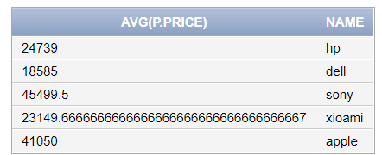

1. **Select the names of manufacturer whose products have an average price larger than or equal to $150**.

select m.name , avg(p.price) from manufactureres m join products p on p.manufacturer = m.code_PK group by m.name having avg(p.price)>=150;

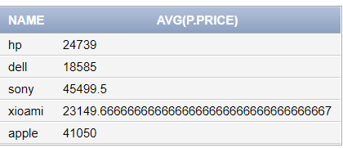

1. **Select the name and price of the cheapest product.**

select name , price from products where price = (select min(price) from products );

